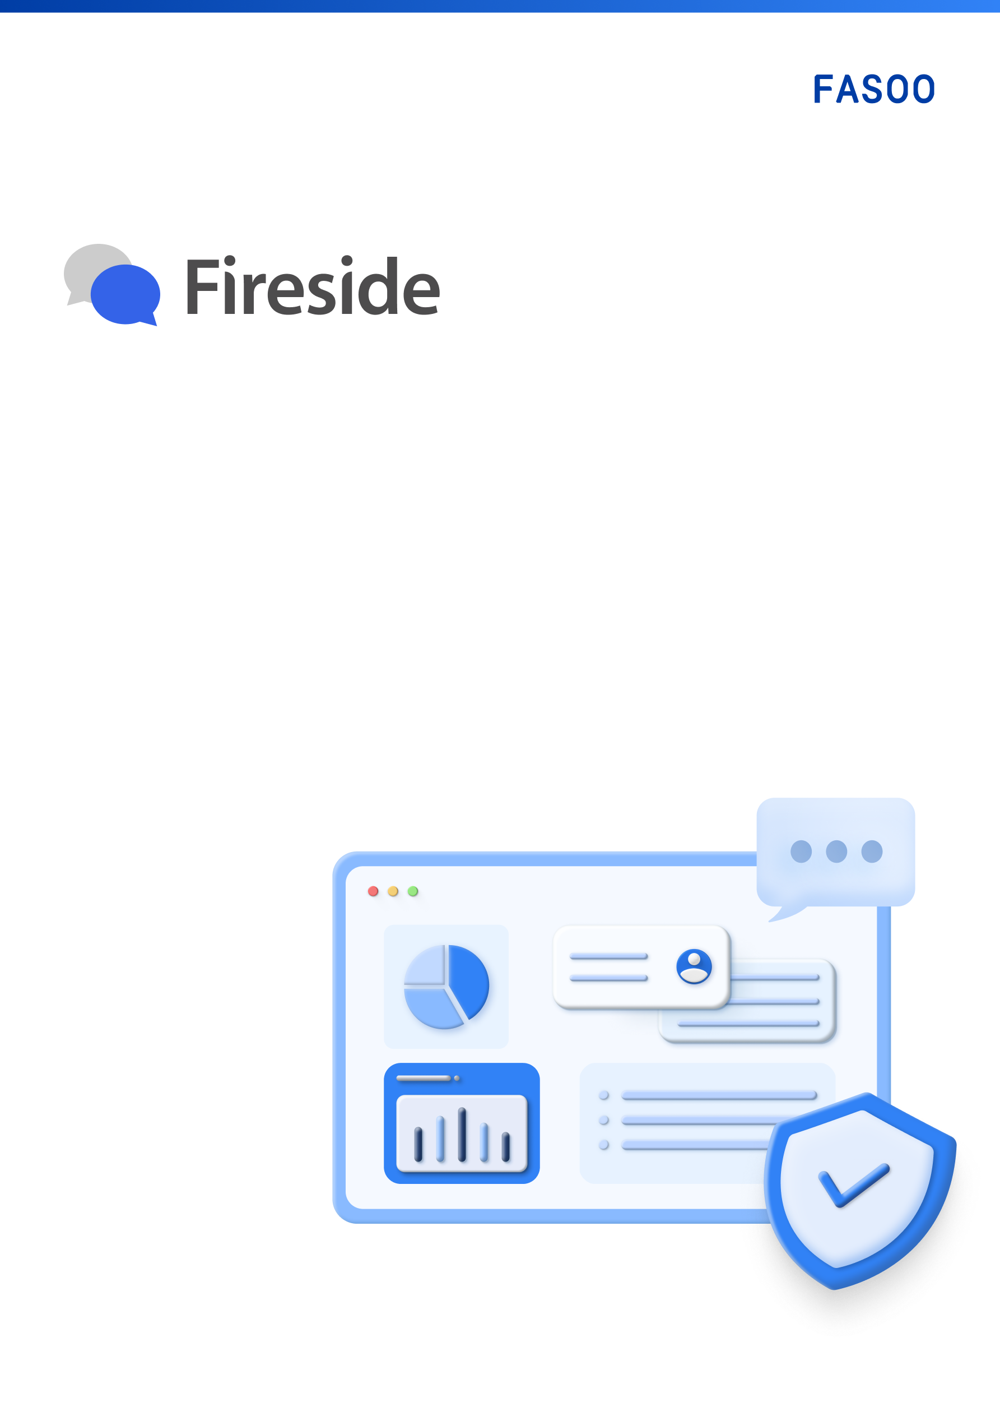

Admin Guide
v2.0
Legal Notice
This guide explains how to configure and use Fireside provided by Fasoo, Inc. The contents of this document and the programs specified in it are protected by applicable copyright laws. This document and the programs explained in it may only be used under a license agreement with Fasoo, Inc. No part of this document may be transmitted, copied, distributed, or reproduced by any means (electronic, mechanical, recording, or otherwise) without written permission of Fasoo, Inc. Information in this document is subject to change without notice as improvements are made to the product.

Technical Support
Sales information: | inquiry@fasoo.com
Help desk: | helpdesk@fasoo.com
Website: | http//www.fasoo.com ​
North America HQ | Global HQ
Fasoo, Inc.  6707 Democracy Blvd.  Bethesda, MD 20817, USA  Tel: +1-732-955-2333 | Fasoo Co., Ltd.  17th Fl. Nuritkum Square Business Tower  396 World Cup Buk-ro, Mapo-gu  Seoul, Korea  Tel: +82-2-300-9000

Table of contents
Get started with Fireside 5
Introductions 5
Documentation set 5
Terminology 5
System requirements 6
Server 6
Supported web browsers 6
Fireside admin website 6
Login and logout 6
Log in 6
Log out 6
Fireside admin console interface 6
Key features of the Fireside admin console 8
View the overview of Fireside Rooms and messages 8
Check the overview of all Rooms 8
View newly created rooms 8
View recently sent messages 8
View top 10 rooms with most messages sent 8
View top 10 members with most room entries 8
View the total number of messages sent 9
View top 10 users who sent most messages 9
Manage Rooms & Users 9
View the Room list 9
Search for Rooms 9
View the user list 10
Search for users 10
Add users 10
Check Room chat history 10
Export chat history by Room 10
View Room details 11
Block file download in Rooms 11
Unblock file download in Rooms 11
Restore all messages in a Room 11
Delete Rooms 12
Management features for Wrapsody Rooms 12
Sync organizational chart 12
Update Wrapsody Room members 12
System settings 12
View registered external systems 12
Register external systems 13
Receive email content as Fireside notification messages via Outlook's Exchange server 13
Edit external systems 13
Reissue app keys for external systems 14
Delete external systems 14
View registered external chatbot servers 14
Register external chatbot servers 14
Edit external chatbot servers 14
Register slash commands to a chatbot 15
Add or delete slash commands for a chatbot 16
Reissue secret keys for external chatbot servers 17
Delete external chatbot servers 17
Set up user info 17
Add user status options 17
Edit user status option information 17
Delete user status information 17
Set up admins 18
Add admins 18
Edit types for an admin 18
Delete admins 18
Set up policies and general settings 19
Configure words to block message sending 19
Set message restoration periods 19
Configure content download availability 19

Revisions
Date revised | Description
May 24, 2024 | v1.7 created
Aug. 16, 2024 | Updated for v1.7.1
Nov. 14, 2024 | Updated for v2.0

Get started with Fireside

Introductions
As hybrid work environments become more common, companies and organizations are increasingly adopting internal messengers and various collaboration tools to boost productivity. However, they still face numerous issues such as inconsistencies between collaborative content and messenger conversations, and reduced security levels. By using Fasoo Fireside, you can establish an efficient collaboration environment while securely protecting important materials during the collaborative process.
Efficient Communication Centered on Secure Documents
Rooms (chat rooms) are created for each secure document, enabling content-centric communication. You can view real-time updates of documents within the messenger and chat in the document preview window on the web browser, making communication more
Messaging Hub through Intuitive Integration with Internal Systems
Fireside offers chat features integrated with internal systems, MS Office applications, and web browsers, and provides a user-friendly UI/UX to maximize user convenience.
AI-Integrated Interactive Work Interface
You can utilize AI chatbots. The AI chatbot assists with various tasks such as document search, creation, business meetings, and document summarization.

Documentation set
Fireside User Guide for Windows: Instructions for employees on using Fasoo Fireside in a Windows desktop environment.
Fireside User Guide for Mobile: Instructions for employees on using Fasoo Fireside in a mobile environment.
Fireside Admin Guide: Instructions for administrators on managing Rooms and users, and configuring settings in the Fireside admin console.

Terminology
Room: Refers to a chat room established in Fireside.
Fireside Room: A Room created by a user, which can be either 1:1 or a group Room.
Wrapsody Room: A Room automatically created when a Wrapsody file is generated. Users with permissions for the file are automatically included as members, allowing communication centered around the file. Wrapsody Rooms can only be created when using Fasoo's Wrapsody.
Wrapsody: Fasoo's content-centric file management application. It stores all files as secure files and generates versions each time modifications are made, allowing version-by-version file management.
AI Assistant: This feature is available in Wrapsody Rooms generated based on Wrapsody files. You can freely ask questions about the file and receive answers from AI Assistant. This feature is available only to organizations that have adopted Wrapsody with AI integration.
Fireside Administrator: Manages Fireside user accounts within the organization and sets various policies. There are two types of Fireside Administrators: Super Admins and Regular Admins. Super Admins have access to all menus in the admin console, while Regular Admins cannot access admin settings, Room content viewing, and Room message recovery features.

System requirements

Server
- HW
- CPU
Xeon 2.5 GHz Quad Core or faster
- RAM
16GB or more (32GB or more recommended)
- HDD
100GB or more (separate storage)
- OS
Windows Server 2012 or more (64bit)
- DB
MS-SQL 2012 / Oracle 11g / MySQL 5.6.4 / Maria DB 10.2 or more
- JDK
v1.7 or more

Supported web browsers
- Google Chrome
- Microsoft Edge (Windows only)
- Safari (Mac only)
- Naver Whale

Fireside admin website
The default address for the Fireside admin website is as follows:
https://[domain name]:[service port]/wrapmsgr/admin/login
For the exact Fireside Admin Website address, please contact your Fasoo sales representative.

Login and logout

Log in
- Access the Fireside admin website.
- Enter your User ID and Password.
- Click Log in.

Log out
- Access the Fireside admin website.
- Click the profile icon in the top right corner.
- Select Log out. You will be logged out immediately without any confirmation process.

Fireside admin console interface
Here are the main areas of the Fireside admin console:
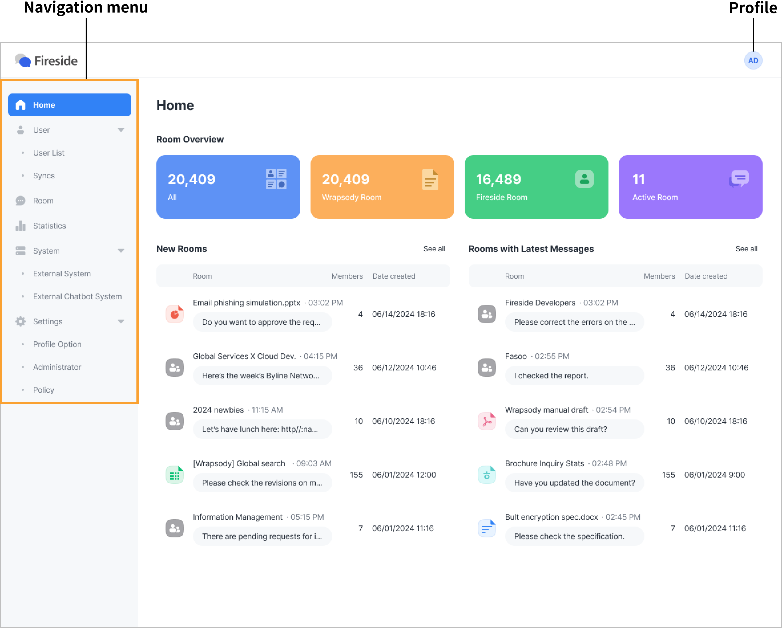
Navigation menu
- Home: Provides an overview of Rooms created in Fireside.
- User: Displays the list of Fireside users and offers synchronization features.
- Room: Displays the list of created Rooms and provides Room management features.
- Statistics: Shows trends such as the number of Rooms and sent messages, and provides data on Room activity and user engagement rates.
- System: Offers features for registering systems or chatbots to integrate with Fireside.
- Settings: Provides features for managing user information, admins, and policies.
Profile
Allows you to log out.
Home
- Room Overview: Shows the total number of Rooms created, including Wrapsody and Fireside Rooms.
- New Rooms: Lists the five most recently created Rooms.
- Rooms with Latest Messages: Lists the five Rooms with the most recent messages.

Key features of the Fireside admin console

View the overview of Fireside Rooms and messages

Check the overview of all Rooms
You can quickly see the total number of Rooms created to date, including both Wrapsody Rooms and Fireside Rooms.
Note: The All category includes Wrapsody Rooms, Fireside Rooms, as well as Rooms from integrated systems or chatbots. Active Rooms are those with messages sent within the last three days.
Route 1. Home
- Access the Fireside admin website.
- Go to the Home page.
- The numbers for All, Wrapsody Room, Fireside Room, and Active Room are displayed at the top.
Route 2. Statistics
- Access the Fireside admin website.
- Click Statistics from the navigation menu.
- The Total Rooms by type graph shows the daily counts for All, Wrapsody Room, Fireside Room, and Active Room.

View newly created rooms
- Access the Fireside admin website.
- Go to the Home page.
- The New Rooms section lists the five most recently created Rooms.
Note: Each listed Room shows the Room name, content of the latest message, and the date it was sent. It also includes details on the Room's members and creation date.

View recently sent messages
- Access the Fireside admin website.
- Go to the Home page.
- The Rooms with Latest Messages section displays the most recent messages.
Note: Each listed Room shows the Room name, content of the latest message, and the date it was sent. It also includes details on the Room's members and creation date.

View top 10 rooms with most messages sent
- Access the Fireside admin website.
- Click Statistics from the navigation menu.
- In the Daily Top 10 section, find Rooms with most messages sent, which lists the 10 Rooms with the highest number of messages sent in a day.

View top 10 members with most room entries
- Access the Fireside admin website.
- Click Statistics from the navigation menu.
- In the Daily Top 10 section, find Members who joined most rooms, which lists the 10 users who joined the most Rooms in a day.
Note: New entries include users who either create their own Rooms or join Rooms through invitations from other users.

View the total number of messages sent
- Access the Fireside admin website.
- Click Statistics from the navigation menu.
- Click the Messages tab.
- The Total messages sent graph displays the cumulative number of messages sent.

View top 10 users who sent most messages
- Access the Fireside admin website.
- Click Statistics from the navigation menu.
- Click the Messages tab.
- In the Daily Top 10 section, find Users who sent most messages, which lists the 10 users who sent the most messages in a day.

Manage Rooms & Users
You can view and manage all Rooms and users created in Fireside, including Fireside Rooms, Wrapsody Rooms, and Rooms integrated with servers.

View the Room list
View all Rooms created in Fireside.
Item | Description
Last 3 months dropdown button | Set the period to include the Room creation date.
Room | Room name and latest message
Members | Number of members in the Room
Last messaged | Date and time of the last message sent in the Room
More icon | Menu containing functions to manage the Room
Route 1. Room
- Access the Fireside admin website.
- Click Room from the navigation menu.
- The All tab opens, displaying all Rooms created in Fireside.
Note: Selecting the Fireside Room or Wrapsody Room tab will list only Rooms of that type.
Route 2. Home
- Access the Fireside admin website.
- Go to the Home page.
- Click See all in the New Rooms or Rooms with Latest Messages section.
- You will be directed to Room > All tab, where all Rooms created in Fireside are listed.

Search for Rooms
You can find Rooms that meet specific criteria using the search function.
- Access the Fireside admin website.
- Click Room from the navigation menu.
- Enter a Room name, user name, or user ID into the search bar in the top right corner and press Enter.
- A list of Rooms matching the criteria will appear.
Note: You can also search for Rooms by entering part of the message content.

View the user list
View all users registered in Fireside.
- Access the Fireside admin website.
- Click User > User List from the navigation menu.
- The total number of users in Fireside, along with the user list, will be displayed, along with the organizational chart.

Search for users
You can search for users registered in Fireside.
- Access the Fireside admin website.
- Click User > User List from the navigation menu.
- To search for users in a specific group, enter the group name in the group search field at the top left and click the desired one (optional).
- In the user search field at the top right, you can search by user name, user ID, group, job title, email address, etc.
- Users matching the entered criteria will appear in the results.

Add users
To add users to Fireside, please contact your Fasoo sales representative.

Check Room chat history
Super admins can view chat histories for each Room. For Wrapsody Rooms, if the admin does not have permission for the Wrapsody file, they will not see a document preview but will still see the chat history.
Note: The Open Room option is only accessible to super admins; regular admins cannot access it.
- Access the Fireside admin website.
- Click Room from the navigation menu.
- The All tab opens, displaying all Rooms created in Fireside.
Note: Selecting the Fireside Room or Wrapsody Room tab will list only Rooms of that type.
- Click the More icon on the far right of the desired Room.
- Click Open Room.
- The message history for the Room will be displayed.
Note: Clicking the search button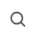 in the top right corner of the Room will open the search bar. Enter a file name or message text and press Enter to find Rooms that match the search criteria.

Export chat history by Room
Super admins can download chat history by Room as a text (.txt) file for review.
Note: The Export Chat option is only accessible to super admins; regular admins cannot access it.
- Access the Fireside admin website.
- Click Room from the navigation menu.
- The All tab opens, displaying all Rooms created in Fireside.
Note: Selecting the Fireside Room or Wrapsody Room tab will list only Rooms of that type.
- Click the More icon on the far right of the desired Room.
- Click Export Chat.
- A text file containing the chat history for the Room will be downloaded.

View Room details
The Room details include the following information: Room name, Room type, Date created, Shared files, Members.
For Wrapsody Rooms, additional details such as Date uploaded, Owner, Last revised by, View permission, and Revise permission will also be displayed.
- Access the Fireside admin website.
- Click Room from the navigation menu.
- The All tab opens, displaying all Rooms created in Fireside.
Note: Selecting the Fireside Room or Wrapsody Room tab will list only Rooms of that type.
- Click the desired Room to expand the details pane on the right.

Block file download in Rooms
Prevent members from downloading shared files in a Room.
- Access the Fireside admin website.
- Click Room from the navigation menu.
- The All tab opens, displaying all Rooms created in Fireside.
Note: Selecting the Fireside Room or Wrapsody Room tab will list only Rooms of that type.
- Click the More icon on the far right of the desired Room.
- Click Block Download.
- In the Block Download confirmation dialog, click Block.
- The Block Download icon will appear next to the Room.

Unblock file download in Rooms
Allow members to download shared files in a Room again.
- Access the Fireside admin website.
- Click Room from the navigation menu.
- The All tab opens, displaying all Rooms created in Fireside.
Note: Selecting the Fireside Room or Wrapsody Room tab will list only Rooms of that type.
- Click the More icon on the far right of the Room with the Block Download icon.
- Click Unblock Download.
- In the Unblock Download confirmation dialog, click Unblock.
- The Block Download icon will disappear for the Room.

Restore all messages in a Room
Super admins can restore all messages, including content, for a Room in one action. Only messages within the restorable period can be restored.
Note: The Restore Messages option is only accessible to super admins; regular admins cannot access it.
- Access the Fireside admin website.
- Click Room from the navigation menu.
- The All tab opens, displaying all Rooms created in Fireside.
Note: Selecting the Fireside Room or Wrapsody Room tab will list only Rooms of that type.
- Click the More icon on the far right of the desired Room.
- Click Restore Messages.
- In the Restore Messages confirmation dialog, click Restore.

Delete Rooms
When you delete a Room, it will be removed from the users' Room list.
Important: Deleted Rooms cannot be restored.
- Access the Fireside admin website.
- Click Room from the navigation menu.
- The All tab opens, displaying all Rooms created in Fireside.
Note: Selecting the Fireside Room or Wrapsody Room tab will list only Rooms of that type.
- Click the More icon on the far right of the desired Room.
- Click Delete.
- In the Delete Room confirmation dialog, click Delete.
Note: When deleting a Room from an integrated system, it will disappear from the users' Room list, but the system registration will remain intact.

Management features for Wrapsody Rooms
If the Fireside is integrated with Wrapsody, you can use Wrapsody file features within a Wrapsody Room. For detailed instructions, refer to the Fireside User Guide for Desktop.

Sync organizational chart
Update the organizational chart on the server to the client.
- Access the Fireside admin website.
- Click User > Syncs from the navigation menu.
- In the Org chart section, click the Run button next to Org chart sync.
- While the sync is in progress, the button label will display Syncing.
- Once the sync is complete, a "Synchronized successfully." message will briefly appear at the top of the screen.

Update Wrapsody Room members
Update Wrapsody Room members based on the current permissions for the Wrapsody file.
- Access the Fireside admin website.
- Click User > Syncs from the navigation menu.
- In the Room members section, click the Run button next to Wrapsody Room member sync.
- While the sync is in progress, the button label will display Syncing.

System settings
Integrate external systems or chatbots with Fireside to enhance user convenience. Once an external system is registered, Fireside can pull in real-time information from that system. Similarly, registering an external chatbot can improve the user experience by providing services such as information retrieval.

View registered external systems
You can view the external systems integrated with Fireside. The displayed information includes System name, Description, Server ID, Server URL, and Date registered.
- Access the Fireside admin website.
- Click System > External System from the navigation menu.
- A list of registered external systems will be displayed.

Register external systems
Register an external system to integrate with Fireside.
- Access the Fireside admin website.
- Click System > External System from the navigation menu.
- Click the Add button in the upper right corner.
- The Add External System window will appear.
- Enter the Name of the external system, which will be displayed as the Room name in Fireside, and the Server URL of the system to be integrated.
- Click the Register button.
- The system will be added, and a Server ID and App Key will be issued.
Note: The issued App Key is only displayed when the system is added.
- If you add a Description or Email address, click the Save button in the lower right corner to save the details.
Note: Use the issued Server ID and App Key in the external system to enable communication with Fireside.

Receive email content as Fireside notification messages via Outlook's Exchange server
By registering Outlook's Exchange server as an external system, emails received at the specified email address will be sent as notification messages to the corresponding Room in Fireside.
- Access the Fireside admin website.
- Click System > External System from the navigation menu.
- Click the Add button in the upper right corner.
- The Add External System window will appear.
- Enter the name of the external system in the Name field, which will be displayed as the Room name in Fireside. In the Server URL field, enter the URL of the Outlook Exchange server to be integrated.
- Click the Register button.
- The system will be added, and a Server ID and App Key will be issued.
- Enter the email address where emails will be received from the Exchange server in the Email address field. Optionally, provide a description.
- Click Save.
Note: Use the issued Server ID and App Key in the external system to enable communication with Fireside. The App Key is only displayed at the time of system registration.

Edit external systems
Modify the information of a registered external system.
- Access the Fireside admin website.
- Click System > External System from the navigation menu.
- Hover over a registered external system and click the Edit button on the far right.
- After making changes, click the Save button.
- The modifications will be reflected in the registered external system.

Reissue app keys for external systems
Reissue the app key for a registered external system.
- Access the Fireside admin website.
- Click System > External System from the navigation menu.
- Hover over a registered external system and click the Edit button on the far right.
- In the App Key Info section, click Reissue App Key.
- The reissued app key will be displayed.
Note: Once you click the Reissue App Key button, the reissue process cannot be undone. Additionally, the reissued app key will not be displayed again once you leave the system modification page.

Delete external systems
Delete a registered external system.
- Access the Fireside admin website.
- Click System > External System from the navigation menu.
- Hover over a registered external system and click the Delete button on the far right.
- In the Delete System window, click Delete.

View registered external chatbot servers
You can view the external chatbot servers integrated with Fireside. The displayed information includes Server name, Description, Server ID, Server URL, and Date registered.
- Access the Fireside admin website.
- Click System > External Chatbot Server from the navigation menu.
- A list of registered external chatbots will appear.

Register external chatbot servers
Register an external chatbot server to integrate with Fireside.
- Access the Fireside admin website.
- Click System > External Chatbot Server from the navigation menu.
- Click Add in the top right corner.
- The Add External Chatbot Server window will appear.
- Enter the Name of the external chatbot (as it will appear in Fireside) and the Server URL of the chatbot you want to integrate.
- Click the Register button.
- The server will be added, and a Server ID and Secret Key will be issued.
Note: The issued Secret Key is only displayed when the server is added.
- If you want to add a Description of the chatbot or any Slash Commands that users can use with this chatbot, enter the details and click the Save button in the bottom right corner to save the information.
Note: You can register the chatbot server to communicate with Fireside using the issued Server ID and Secret Key. If you develop the chatbot server’s functionality or register slash commands, users will be able to use them easily in Fireside. The chatbot server can be easily developed using the Fireside ChatBot Library.

Edit external chatbot servers
Modify the information of a registered external chatbot server.
- Access the Fireside admin website.
- Click System > External Chatbot Server from the navigation menu.
- Hover over a registered external chatbot server and click the Edit button on the far right.
- After making changes, click the Save button.
- The modifications will be reflected in the registered chatbot server.

Register slash commands to a chatbot
Register slash commands that users can use in the chat for each chatbot.
Each slash command consists of the format [command_name] [parameter]: [description]. After entering one slash command, press the Enter key before entering the next one.
Note: “Parameter” and “Description” are optional fields.
Example:
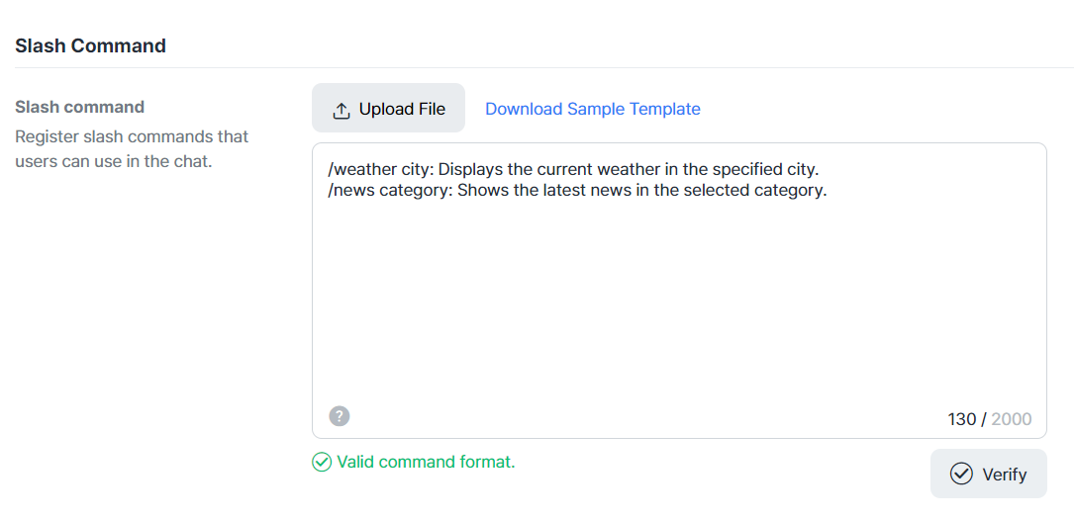

Register slash commands when adding a server
- Access the Fireside admin website.
- Click System > External Chatbot Server from the navigation menu.
- Click Add in the top right corner.
- The Add External Chatbot Server window will appear.
- Enter the Name of the external chatbot (as it will appear in Fireside) and the Server URL of the chatbot you want to integrate.
- Click the Register button.
- The server will be added, and a Server ID and Secret Key will be issued.
Note: The issued Secret Key is only displayed when the server is added.
- In the Slash command input field, enter the slash commands that users will be able to use in the chatbot server.
- Click the Verify button to start the validation process and check if the commands are valid.
- If the message “Valid command format.” appears, click Save.

Register slash commands on the Edit Server page
- Access the Fireside admin website.
- Click System > External Chatbot Server from the navigation menu.
- Hover over a registered external chatbot server and click the Edit button on the far right.
- You will be taken to the Edit Server page.
- In the Slash command input field, enter the slash commands that users will be able to use in the chatbot server.
- Click the Verify button to start the validation process and check if the commands are valid.
- If the message “Valid command format.” appears, click Save.
Note: When saving modifications, the Server ID and Secret Key will not be reissued.

Register slash commands via file upload when adding a server
- Access the Fireside admin website.
- Click System > External Chatbot Server from the navigation menu.
- Click Add in the top right corner.
- The Add External Chatbot Server window will appear.
- Enter the Name of the external chatbot (as it will appear in Fireside) and the Server URL of the chatbot you want to integrate.
- Click the Register button.
- The server will be added, and a Server ID and Secret Key will be issued.
Note: The issued Secret Key is only displayed when the server is added.
- In the Slash Command section, click the Upload File button.
- Select a CSV or JSON file that contains the slash commands and click Open.
Note: You can download a sample CSV or JSON file for slash commands by clicking Download Sample Template.
- The slash commands from the file will be entered into the input field.
- Click the Verify button to start the validation process and check if the commands are valid.
- If the message “Valid command format.” appears, click Save.

Register slash commands via file upload on the Edit Server page
- Access the Fireside admin website.
- Click System > External Chatbot Server from the navigation menu.
- Hover over a registered external chatbot server and click the Edit button on the far right.
- You will be taken to the Edit Server page.
- In the Slash Command section, click the Upload File button.
- Select a CSV or JSON file that contains the slash commands and click Open.
Note: You can download a sample CSV or JSON file for slash commands by clicking Download Sample Template.
- The slash commands from the file will be entered into the input field.
- Click the Verify button to start the validation process and check if the commands are valid.
- If the message “Valid command format.” appears, click Save.
Note: When saving modifications, the Server ID and Secret Key will not be reissued.

Add or delete slash commands for a chatbot
Add or delete slash commands that users can use in the chat for each chatbot.
- Access the Fireside admin website.
- Click System > External Chatbot Server from the navigation menu.
- Hover over a registered external chatbot server and click the Edit button on the far right.
- In the Slash Command input field, add or delete the slash commands that users can use in the chatbot.
- Click the Verify button to start the validation process and check if the commands are valid.
- If the message “Valid command format.” appears, click Save.
- The modifications will be reflected in the chatbot server.
Note: When saving modifications, the Server ID and Secret Key will not be reissued.

Reissue secret keys for external chatbot servers
Reissue the secret key for a registered external chatbot server.
- Access the Fireside admin website.
- Click System > External Chatbot Server from the navigation menu.
- Hover over a registered external chatbot server and click the Edit button on the far right.
- In the Secret Key Info section, click the Reissue Secret Key button.
- The reissued secret key will be displayed.
Note: Once you click the Reissue Secret Key button, the reissue process cannot be undone. Additionally, the reissued secret key will not be displayed again once you leave the server modification page.

Delete external chatbot servers
Delete a registered external chatbot server.
- Access the Fireside admin website.
- Click System > External Chatbot Server from the navigation menu.
- Hover over a registered external chatbot server and click the Delete button on the far right.
- In the Delete System window, click Delete.

Set up user info
Modify user-related information.

Add user status options
Add status options that can be selected from a user profile.
- Access the Fireside admin website.
- Click Settings > Profile Option from the navigation menu.
- Click the Add button in the upper-right corner.
- The Add Status window will appear.
- Enter the Status name and select whether to enable Push notifications.
Note: If you select Disable for Push notifications, users with this status will not be notified when messages are received.
- Click Save.

Edit user status option information
Modify the information for status options that can be selected from a user profile.
- Access the Fireside admin website.
- Click Settings > Profile Option from the navigation menu.
- Hover over the status you want to modify and click the Edit button.
- The Edit Status window will appear.
- Modify the Status name or Push notification settings.
Note: If you select Disable for Push notifications, users with this status will not be notified when messages are received.
- Click Save.

Delete user status information
Delete status information that can be selected from a user profile.
- Access the Fireside admin website.
- Click Settings > Profile Option from the navigation menu.
- Hover over the status you want to delete and click the Delete button.
- In the Delete Status window, click Delete.

Set up admins
A super admin can designate users within the organization as either a super admin or a regular admin. Regular admins have restricted access to admin settings, room content viewing, and room message restoration features.
Note: The Settings > Administrator section is accessible only to super admins; regular admins cannot access this menu.

Add admins
Add Fireside administrators.
- Access the Fireside admin website.
- Click Settings > Administrator from the navigation menu.
- Click the Add button in the upper-right corner.
- The Add Admin window will appear.
- In the left organizational chart, click the Add button next to the user you want to designate as an admin. Clicking the Add button next to a department will select all members of that department.
- Click the dropdown button next to the selected user or department on the right to choose the admin type.
Note: Regular Admin has restricted access to admin settings, room content viewing, and room message restoration features.
- Click OK.

Edit types for an admin
Modify the type of a Fireside admin.
- Access the Fireside admin website.
- Click Settings > Administrator from the navigation menu.
- Hover over the admin whose type you want to modify and click the Edit button.
- The Type field for the selected user will change to a dropdown menu.
- Click the dropdown button and select either Regular Admin or Super Admin.
Note: Regular admins have restricted access to admin settings, room content viewing, and room message recovery features.
- Click the Apply button on the right to update the admin type. Click the Cancel button if you do not want to apply the changes.

Delete admins
Remove Fireside admins.
- Access the Fireside admin website.
- Click Settings > Administrator from the navigation menu.
- Hover over the admin you want to delete and click the Delete button.
- In the Delete Admin window, click Delete.

Set up policies and general settings

Configure words to block message sending
Set up words that will block message sending. Messages containing these words will be blocked from being sent. You can register up to 500 words, with a maximum of 30 characters per word.
Note: If a scheduled message contains blocked words, the message will fail to send at the scheduled time, and the user who scheduled the message will receive a push notification about the sending failure.

Add words to block message sending
- Access the Fireside admin website.
- Click Settings > Policy from the navigation menu.
- In the Message Sending section, enter a word in the Block sending input field and click Add.
- The entered word will be added to the list.

Delete words that block message sending
- Access the Fireside admin website.
- Click Settings > Policy from the navigation menu.
- In the Message Sending section, click the x icon on the chip for the blocked word to remove it from the list.

Set message restoration periods
Define the period for which deleted messages are retained on the server. Only messages within this restoration period can be recovered by a super admin.
- Access the Fireside admin website.
- Click Settings > Policy from the navigation menu.
- In the Message Retention section, click the dropdown button for the Message restoration period item.
- Select an option from the list or choose Custom and enter the number of days to retain messages.
Note: The maximum value for the Custom option is 999.
- Click Save at the bottom of the Message Retention section.

Configure content download availability
Define the period during which shared files or images can be downloaded from the time of sharing.
- Access the Fireside admin website.
- Click Settings > Policy from the navigation menu.
- In the Download section, click the dropdown button for the Content download period item.
- Select an option from the list or choose Custom and enter the number of days for download availability.
Note: The maximum value for the Custom option is 999.
- Click Save at the bottom of the Download section.

